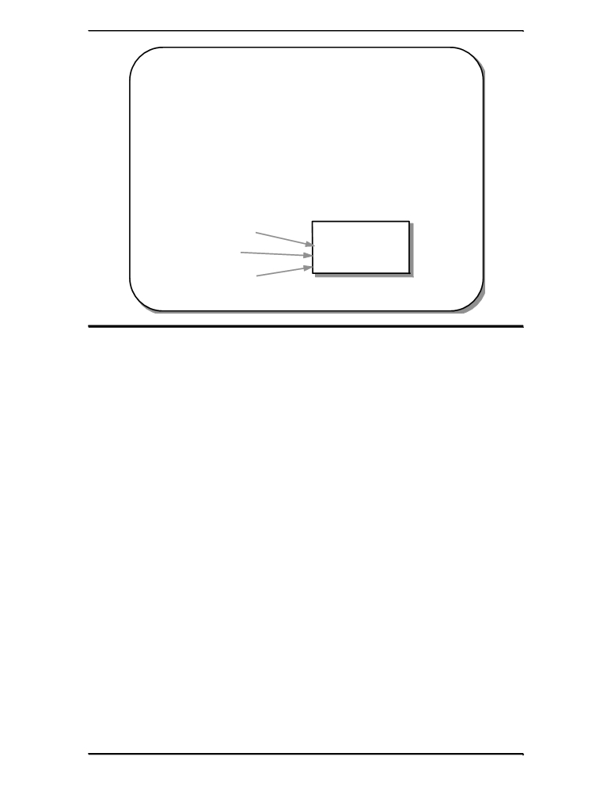

Increment and Decrement

▪ C has two special operators for adding and
subtracting one from a variable
++ increment
- - decrement
▪ These may be either prefix (before the variable) or
postfix (after the variable):

“i” becomes 6

“j” becomes 3

“i” becomes 7

int i = 5, j = 4;

i++;
--j;
++i;

